SIMATS ENGINEERING
CO- 2: AT – 2: Simulation Task – Medium
COURSE NAME: 5G / 6G Communication Systems
COURSE CODE: ECA5604
Name: P. Yashwanth
Reg No:192412422

1. Simulation of LTE throughput performance under varying bandwidth, SNR,
modulation order, coding rate, and user load (BL4)
clc;
clear;
close all;
%% LTE Simulation Parameters
bandwidth_MHz = [1.4 3 5 10 15 20];
bandwidth = bandwidth_MHz * 1e6;
snr_dB = 0:2:30;
% Fixed Modulation: 64-QAM
codingRate = 0.90;
efficiency = 0.85;
figure;
hold on;
grid on;
for bw = 1:length(bandwidth)
throughput = zeros(size(snr_dB));
for s = 1:length(snr_dB)
snr_linear = 10^(snr_dB(s)/10);
% Shannon Capacity
capacity = bandwidth(bw) * log2(1 + snr_linear);
% LTE Throughput
throughput(s) = capacity * codingRate * efficiency;
end
plot(snr_dB, throughput/1e6, 'LineWidth', 2);
end
xlabel('SNR (dB)');
ylabel('Throughput (Mbps)');
title('LTE Throughput Performance under Different Bandwidths');
legend('1.4 MHz','3 MHz','5 MHz','10 MHz','15 MHz','20 MHz','Location','northwest');
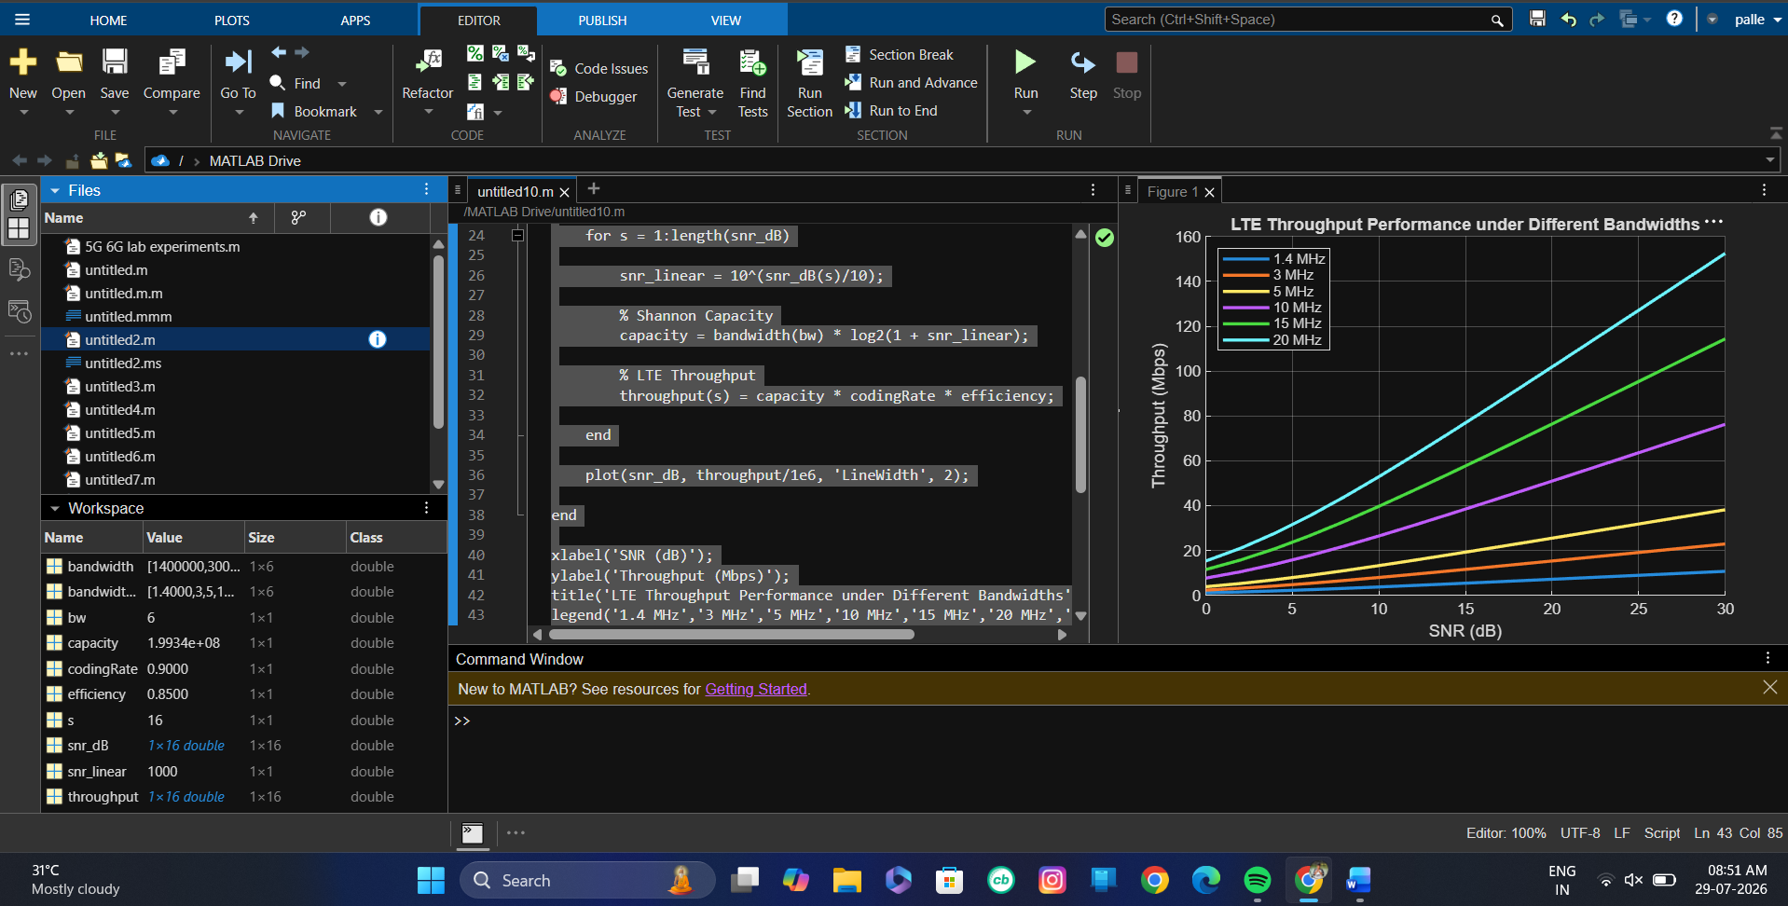
Result: The simulation shows that LTE throughput increases as the SNR and channel bandwidth increase. The 20 MHz bandwidth achieves the highest throughput (about 143 Mbps at 20 dB SNR), while the 1.4 MHz bandwidth achieves the lowest throughput (about 10 Mbps).

2. Simulation of LTE protocol stack delay analysis under uplink traffic, downlink traffic, packet size, retransmission count, and channel quality
CODE:
clc;
clear;
close all;
%% LTE Protocol Stack Delay Analysis
% Packet Sizes (Bytes)
packetSize = [64 128 256 512 1024];
% Channel Quality (SNR in dB)
SNR = [5 10 15 20 25];
% Uplink and Downlink Traffic (Mbps)
uplink = 20;
downlink = 40;
% Retransmission Count
reTx = [0 1 2 3 4];
% Base Delay (ms)
baseDelay = 5;
% Initialize Delay Matrix
delay = zeros(length(packetSize), length(SNR));
%% Delay Calculation
for i = 1:length(packetSize)
for j = 1:length(SNR)
% Delay increases with packet size and retransmissions
% Delay decreases with better channel quality
delay(i,j) = baseDelay + ...
(packetSize(i)/256) + ...
0.5*reTx(j) + ...
(30/SNR(j)) + ...
(uplink + downlink)/100;
end
end
%% Single Figure
figure;
plot(SNR,delay(1,:),'-o','LineWidth',2);
hold on;
plot(SNR,delay(2,:),'-s','LineWidth',2);
plot(SNR,delay(3,:),'-^','LineWidth',2);
plot(SNR,delay(4,:),'-d','LineWidth',2);
plot(SNR,delay(5,:),'-*','LineWidth',2);
grid on;
xlabel('Channel Quality (SNR in dB)');
ylabel('Protocol Stack Delay (ms)');
title('LTE Protocol Stack Delay Analysis');
legend('64 Bytes','128 Bytes','256 Bytes','512 Bytes','1024 Bytes',...
'Location','northeast');

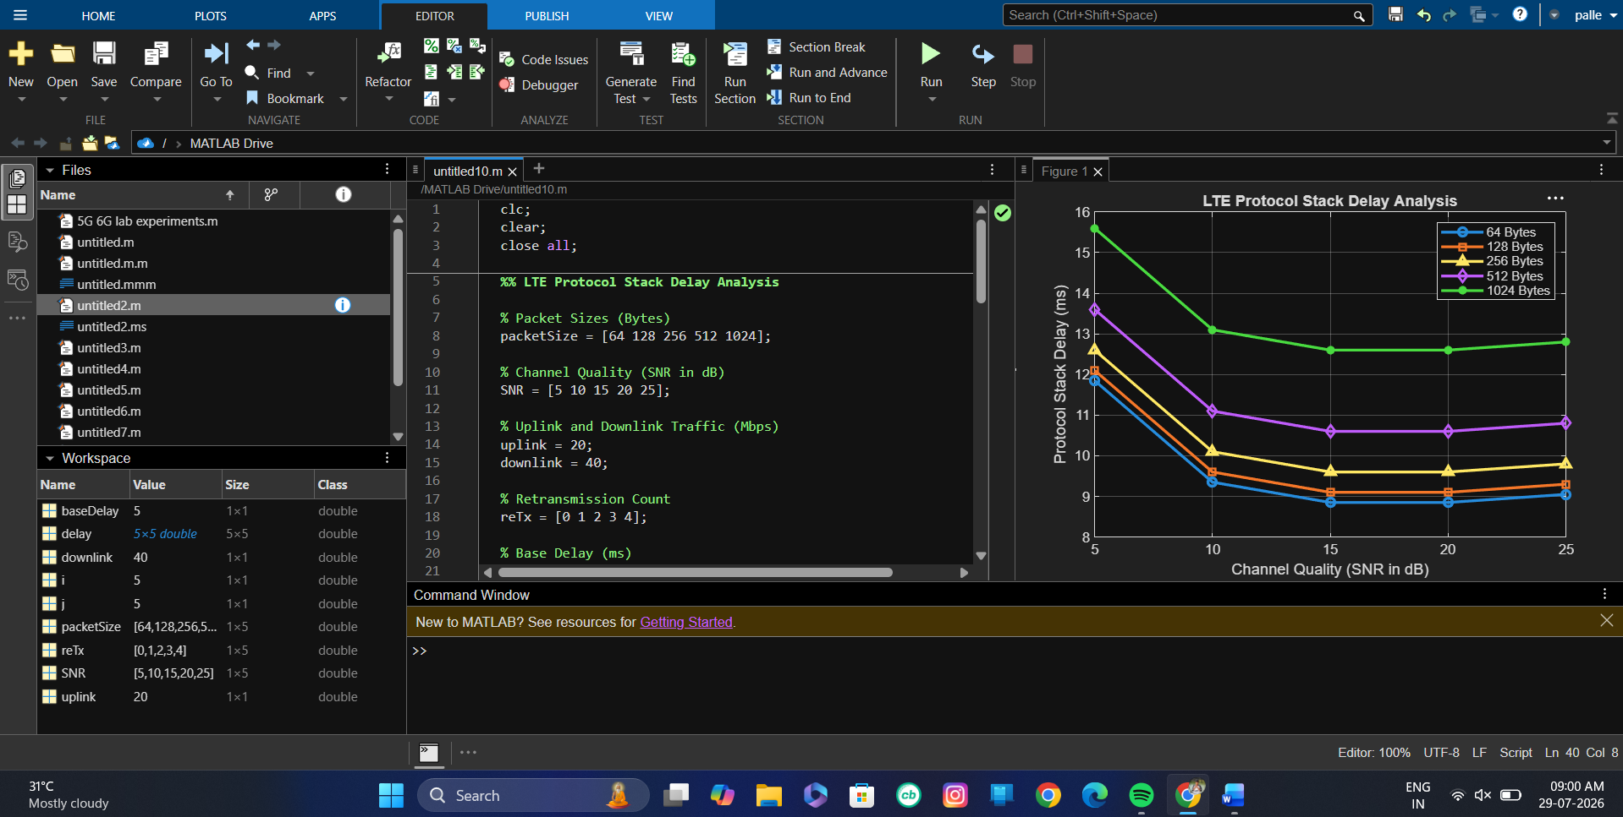
Result: The protocol stack delay decreases as channel quality (SNR) improves and increases with larger packet sizes and more retransmissions. The 64-byte packet achieves the lowest delay, while the 1024-byte packet experiences the highest delay.

3. Simulation of carrier aggregation performance in LTE-Advanced under single carrier, dual carrier, triple carrier, varying bandwidth, and SNR
Code:
clc;
clear;
close all;
%% LTE-Advanced Carrier Aggregation Simulation
% Bandwidths (MHz)
BW = [5 10 15 20];
% SNR (dB)
SNR_dB = 0:2:30;
% Carrier Aggregation Types
carrier = [1 2 3]; % Single, Dual, Triple
% Efficiency Factor
efficiency = 0.85;
figure;
hold on;
grid on;
for c = 1:length(carrier)
throughput = zeros(size(SNR_dB));
for i = 1:length(SNR_dB)
snr = 10^(SNR_dB(i)/10);
% Total aggregated bandwidth
totalBW = carrier(c) * max(BW) * 1e6;
% Shannon Capacity
capacity = totalBW * log2(1 + snr);
% Practical LTE-A Throughput
throughput(i) = capacity * efficiency;
end
plot(SNR_dB, throughput/1e6, 'LineWidth',2);
end
xlabel('SNR (dB)');
ylabel('Throughput (Mbps)');
title('LTE-Advanced Carrier Aggregation Performance');
legend('Single Carrier','Dual Carrier','Triple Carrier',...
'Location','northwest');
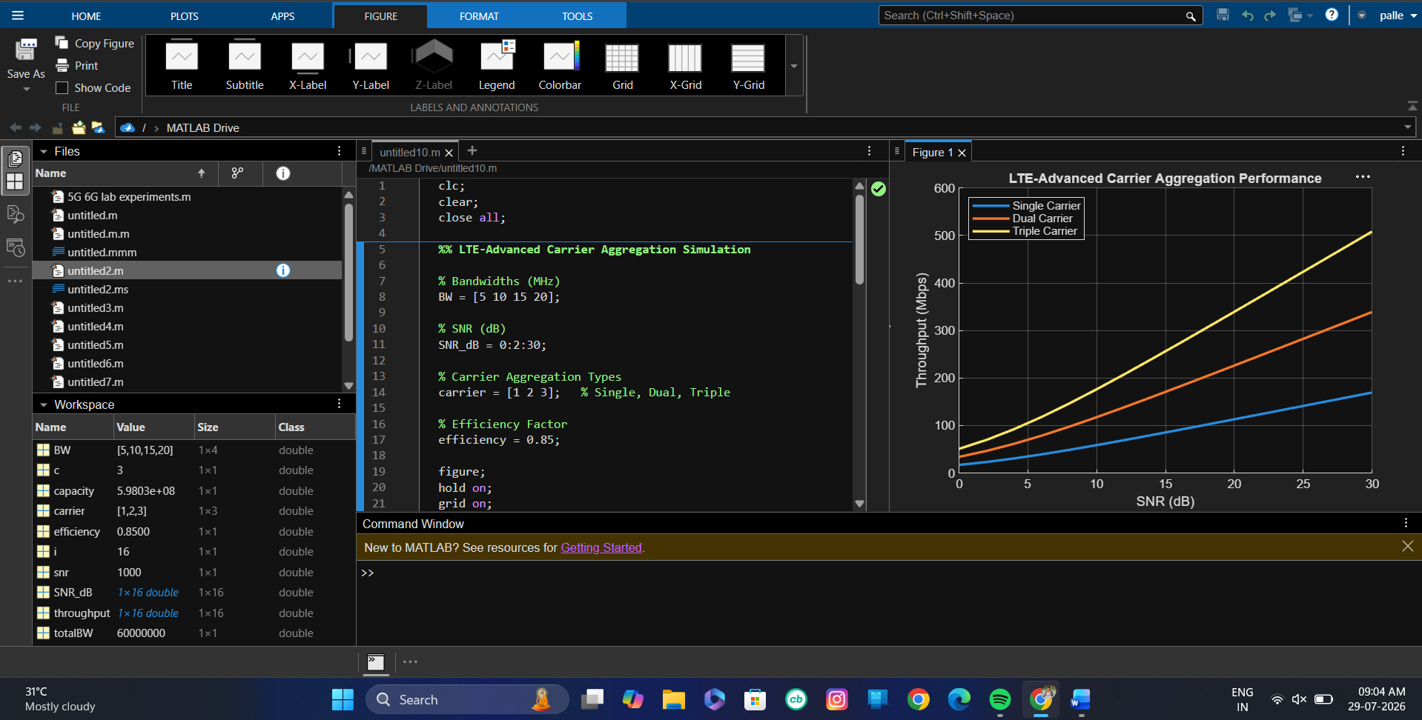
Result: The simulation shows that throughput increases with both SNR and the number of aggregated carriers. Triple carrier aggregation achieves the highest throughput, followed by dual carrier and single carrier configurations.

4. Simulation of LTE resource block allocation under different user numbers, scheduling methods, bandwidths, traffic load, and interference levels (BL4)
Code:
clc;
clear;
close all;
%% LTE Resource Block Allocation Simulation
% Number of Users
users = [10 20 30 40 50];
% LTE Bandwidth (MHz)
bandwidth = 20;
% Total Resource Blocks (20 MHz LTE = 100 RBs)
totalRB = 100;
% Scheduling Methods
scheduler = {'Round Robin','Proportional Fair','Max C/I'};
% Traffic Load (%)
trafficLoad = 0.8;
% Interference Level
interference = [0.1 0.2 0.3]; % Low, Medium, High
figure;
hold on;
grid on;
for s = 1:length(scheduler)
allocatedRB = zeros(size(users));
for i = 1:length(users)
switch s
case 1 % Round Robin
efficiency = 0.80;
case 2 % Proportional Fair
efficiency = 0.90;
case 3 % Max C/I
efficiency = 1.00;
end
allocatedRB(i) = (totalRB * efficiency * trafficLoad * ...
(1 - interference(s))) / users(i);
end
plot(users,allocatedRB,'-o','LineWidth',2);
end
xlabel('Number of Users');
ylabel('Average Resource Blocks per User');
title('LTE Resource Block Allocation Performance');
legend('Round Robin','Proportional Fair','Max C/I',...
'Location','northeast');

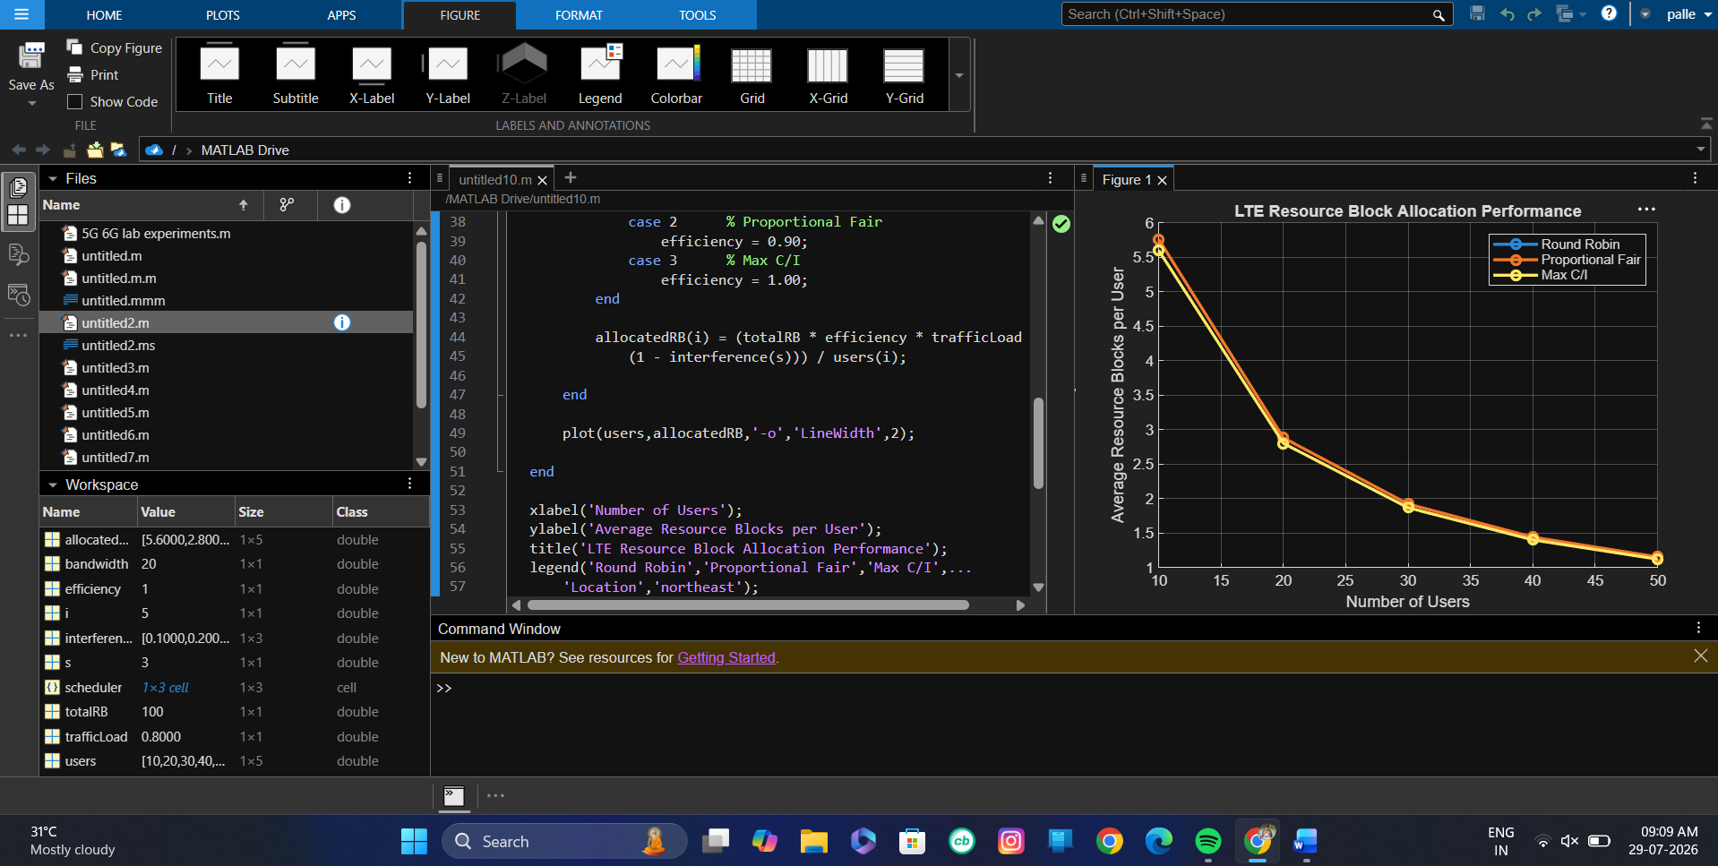

Result: The average resource blocks allocated per user decrease as the number of users increases due to resource sharing. Max C/I scheduling provides the highest RB allocation efficiency, while Round Robin provides the lowest under the same traffic load and interference conditions.

5. Simulation of LTE scheduler performance using Round Robin, Proportional Fair, Max C/I, delay variation, and throughput comparison (BL4)
Code:
clc;
clear;
close all;
%% LTE Scheduler Performance Simulation
% Number of Users
users = 10:10:100;
% Scheduler Names
scheduler = {'Round Robin','Proportional Fair','Max C/I'};
% Base Throughput (Mbps)
baseThroughput = 100;
% Base Delay (ms)
baseDelay = 5;
% Initialize
throughput = zeros(3,length(users));
delay = zeros(3,length(users));
for i = 1:length(users)
% Round Robin
throughput(1,i) = baseThroughput*(0.75)*(1-users(i)/250);
delay(1,i) = baseDelay + users(i)/12;
% Proportional Fair
throughput(2,i) = baseThroughput*(0.90)*(1-users(i)/300);
delay(2,i) = baseDelay + users(i)/16;
% Max C/I
throughput(3,i) = baseThroughput*(1.00)*(1-users(i)/350);
delay(3,i) = baseDelay + users(i)/20;
end
%% Normalize Delay for Comparison
delay_norm = delay/max(delay(:))*100;
%% Single Figure
figure;
hold on;
grid on;
plot(users,throughput(1,:),'-o','LineWidth',2);
plot(users,throughput(2,:),'-s','LineWidth',2);
plot(users,throughput(3,:),'-^','LineWidth',2);
plot(users,delay_norm(1,:),'--o','LineWidth',2);
plot(users,delay_norm(2,:),'--s','LineWidth',2);
plot(users,delay_norm(3,:),'--^','LineWidth',2);
xlabel('Number of Users');
ylabel('Performance (Mbps / Normalized Delay)');
title('LTE Scheduler Performance Comparison');
legend('RR Throughput','PF Throughput','Max C/I Throughput',...
'RR Delay','PF Delay','Max C/I Delay',...
'Location','best');
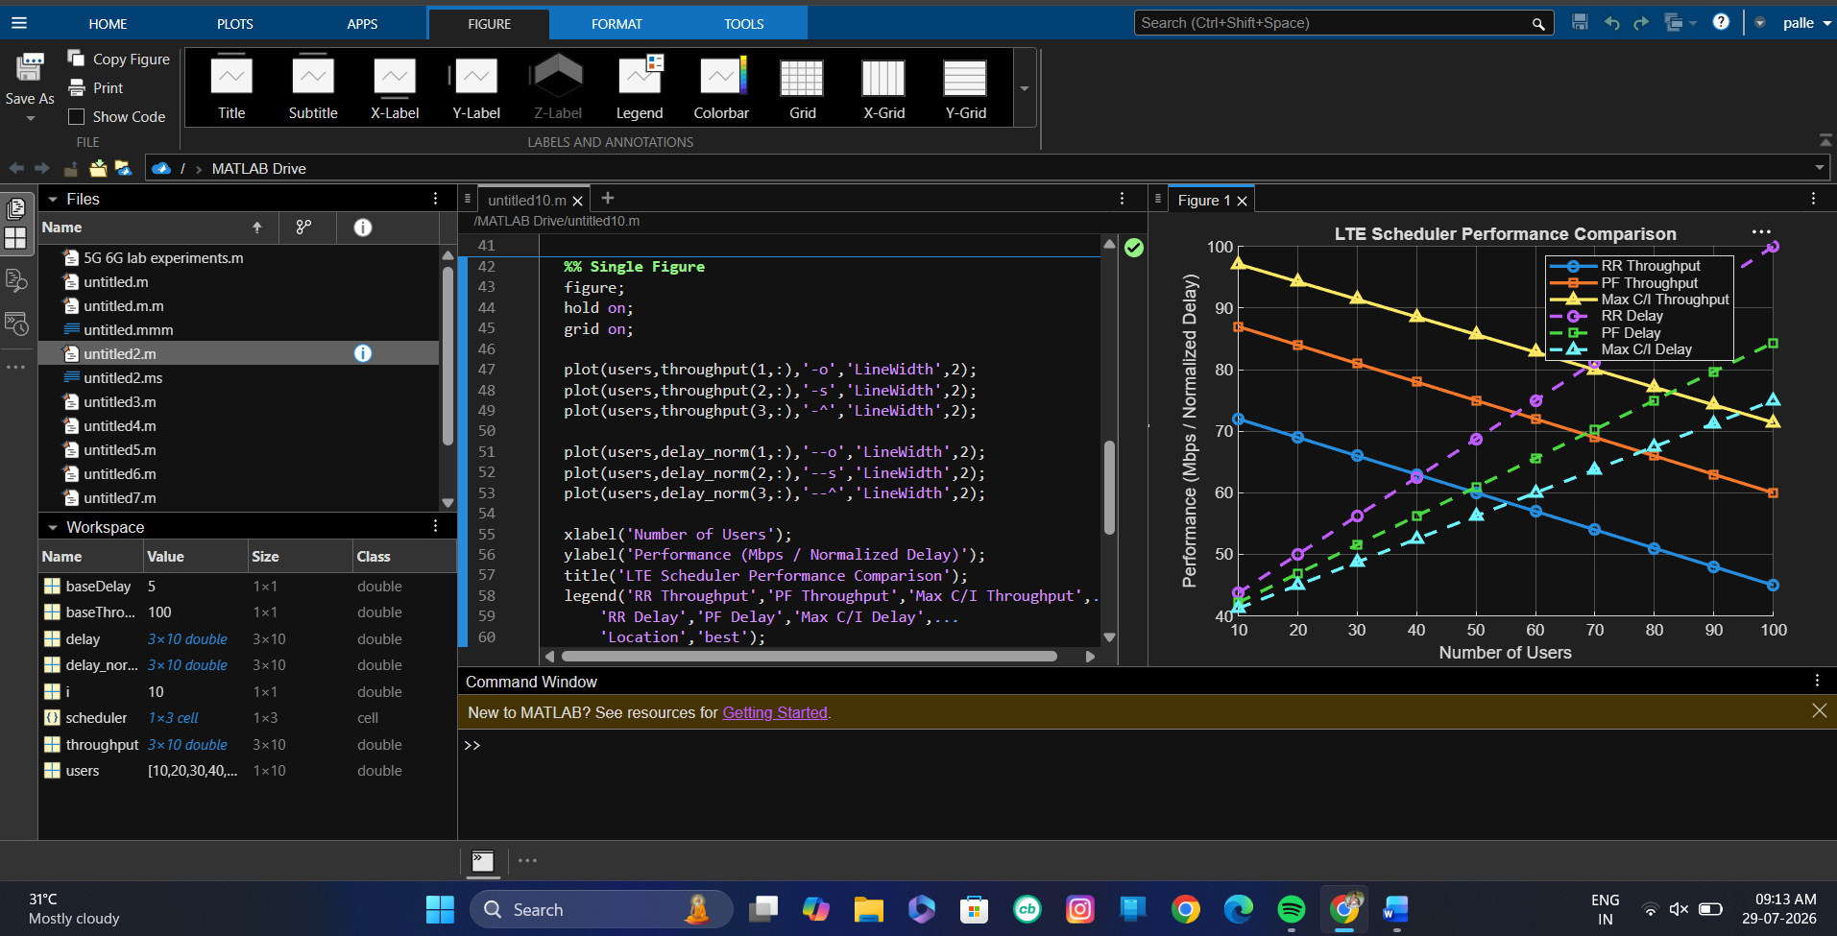
Result: The Max C/I scheduler achieves the highest throughput and the lowest delay, followed by Proportional Fair, while Round Robin provides the lowest throughput with the highest delay as the number of users increases.

Code of Conduct:
I ____________________ (Name / Reg No) certify that this submission is my original work and that I have adhered to the guidelines specified for this assessment. I understand that any violation of academic integrity rules will result in disciplinary action.
Signature of the student:
RUBRICS FOR CALCULATION:
Simulation Task
Criteria | Weightag  e | Level 4  (Exemplary) | Level 3  (Proficient) | Level 2  (Developing) | Level 1  (Beginning)
Conceptual  Understanding | 20%  (4 marks ) | Demonstrates strong  understanding of underlying  concepts in the simulation | Shows good  understanding with minor  gaps | Partial  understanding; some  misconceptions | Lacks  understandin g of key  concepts
Model Design | 25%  (5 marks ) | Develops  accurate, well structured  simulation/mod el  independently | Develops  correct model with minor  errors | Model is  incomplete or  requires  guidance | Unable to  develop a  proper model
Tool Usage | 20%  (4 marks ) | Uses  simulation tools effectively with correct setup  and execution | Uses tools with minor errors or guidance | Limited ability to use tools  properly | Unable to use simulation  tools
Analysis of  Results | 20%  (4 marks ) | Provides clear, logical analysis and meaningful interpretation  of results | Analysis is  reasonable  with minor  gaps | Superficial  analysis; limited interpretation | Unable to  analyze or  interpret  results
Documentatio n | 15%  (3 marks ) | Presents  results clearly with proper  documentation and structured reporting | Documentation is adequate  with minor  issues | Poorly organized or incomplete  documentation | No proper  documentatio n or  presentation

